**Instructions on How to check the status**

**Of K12 Hardware and Materials**:

1. **Log into the learning coach account.**

**WWW.Agoraeagles.org**

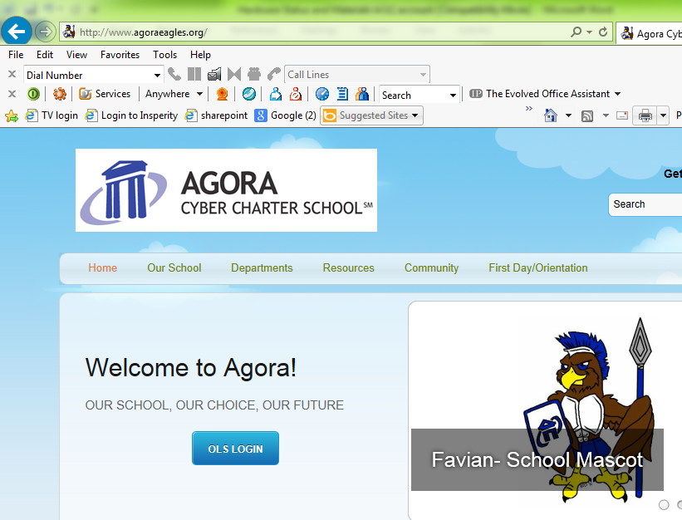

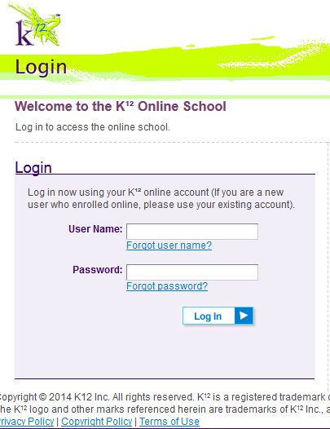

**Click OLS Login - Then Log In**

1. **Under Quick Links select “My Info”**

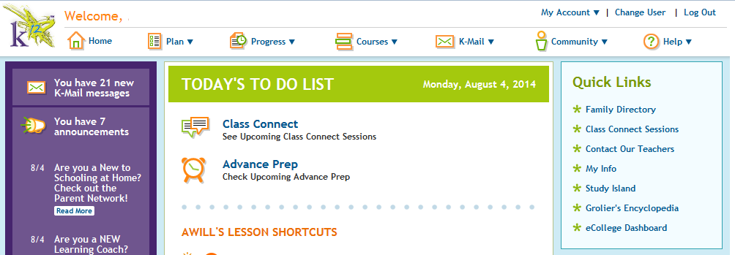

**Click “My Info”**

Sue

**3.Select the student’s name**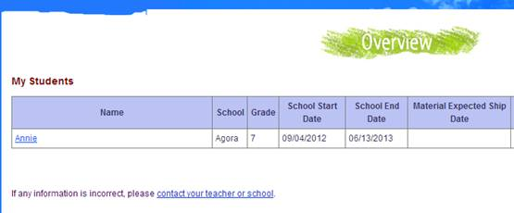

1. **Select Orders to see the status of the student’s materials (click on the order#) .**

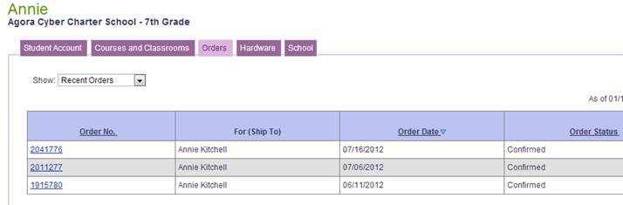

1. **Select Hardware to see the status of the equipment (click on the tracking #).**

